PRESS RELEASE

CONTACT: SARA SEPIDZADEH
sarasefeed@yahoo.com

“1001 Nights” Launches on Disney Southeast Asia
Shahrzad Takes On New Audiences

New York, January 9th, 2010 – Earlier this month, Big Bad Boo’s new show 1001 Nights was launched on the Disney Channel in South East Asia. The station reaches more than 71 million homes in India, Bangladesh, Seychelles, Sri Lanka, Bhutan, Nepal, Maldives and Pakistan in Tamil, Urdu, English, Hindi and Telegu.
“We are so excited to be in the Indian territories with the Disney Channel. Disney is a high quality station with the highest number of viewers in the region. ‘1001 Nights’ is airing in the family hour following comedy shows in the same 6-12 age group like ‘Phineas and Ferb’,” said Aly Jetha, co-creator of the show.
1001 Nights placed #1 Canadian show in the last Mip Jr in Cannes, an event attended by major players in the TV industry. The show was also a finalist in the Mip Jr Licensing Challenge.
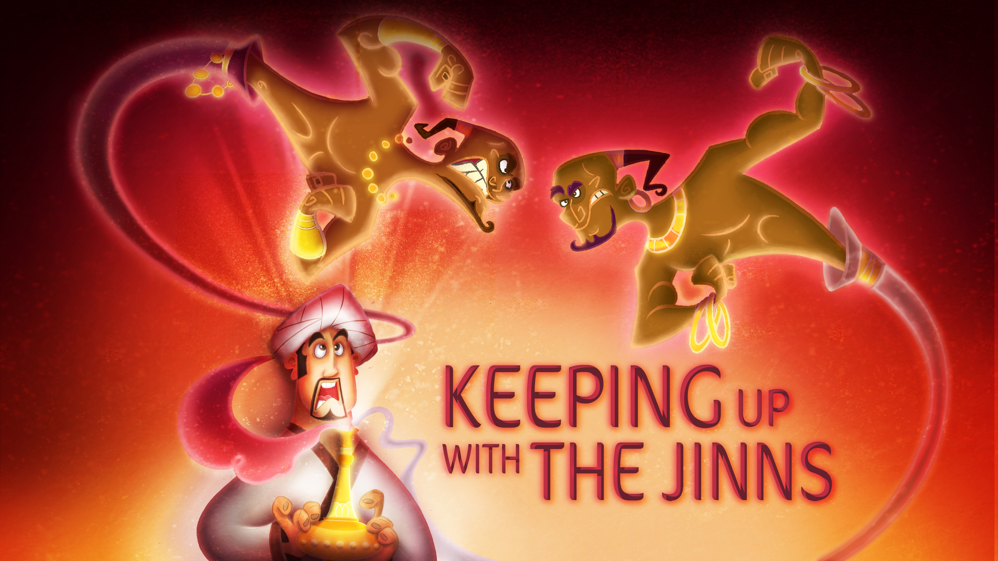
“We are excited to roll out comic books and other merchandising with the show because characters like Shahrzad, Sinbad, Aladdin and the Hunchback are memorable and will keep the kids coming back for more,” added co-creator Shabnam Rezaei. The animated comedy series features the famed storyteller Shahrzad enticing King Shahryar and the Persian court with daily stories of adventure, mystery and comedy. So far the series has also been sold to MTV3 Finland and Al Jazeera Children’s Station in the Middle East among others.

Press Contact: Sara Sepidzadeh sarasefeed@yahoo.com

About 1001 Nights
A new animated comedy series, 1001 Nights is an original show that brings the delightful tales of the famed 1001 Arabian Nights to the screen with hilarity, excitement, and non-stop fast paced action. Filled with exciting stories, vivid animation, wonderful music, and unforgettable characters, 1001 Nights is eye-popping entertainment for both kids and adults. You’ve heard of Sinbad, Aladdin, and Ali Baba? You’ve got 998 more stories to go! 1001 Nights brings them to you in a way that will keep you coming back for more. Join the heroine Shahrzad as she weaves tales of adventure, intrigue, and excitement! www.1001nightsshow.com

About Big Bad Boo Studios
Big Bad Boo is a production dedicated to teaching children culture through entertainment. The company has offices in New York, Los Angeles and Vancouver. Their first product Babak & Friends – A First Norooz was a direct-to-DVD cartoon about the Persian New Year. Their first animated TV series, Mixed Nutz, is now airing on Shaw TV, PBS and major stations around the world. Big Bad Boo is currently working on 1001 Nights. Big Bad Boo provides animation, co-production and development services to clients worldwide. www.bigbadboo.ca. The company’s distribution arm is www.oznoz.com.

About The Walt Disney Company
Disney is a Dow 30 Company, had annual revenues of over US$36 billion in its most recent fiscal year, and a market capitalization of US$65.85 billion as of March 22nd, 2010. The Walt Disney Company (India) Private Limited set up in July 2004 with its head office located in Mumbai. In less than five years, Disney has established a strong foothold in this diverse and highly dynamic market. Disney in India employs nearly 200 employees, and anticipates accelerated growth across Media Networks, Interactive media group, Consumer Products, and Studio businesses. Outside of the U.S., India is one of the largest markets Disney has invested in for local production. The Disney Television Network comprising Disney Channel, Disney XD and Hungama TV has consistently been one of the leading networks for kids in Cable & Satellite (C&S) programming. The network currently reaches over 71 million homes, offering a blend of quality entertainment and distinct original programming that kids love and families trust and enjoy. Through a block called Disney Jadoo on the terrestrial network Doordarshan, Disney Channel reaches over 145 million homes. www.disney.in

